SET-5(DSA0611-DH&V)
AIM
To analyze website traffic data using R programming and visualize page views, click-through rates, and user interactions using different charts.
ALGORITHM
- Start RStudio.
- Create the website traffic dataset containing Date, Page Views, and Click-through Rate.
- Create a line chart to visualize daily page views.
- Sort the data according to Click-through Rate and select the top 3 days.
- Create a bar chart for the top 3 days with the highest Click-through Rate.
- Create user interaction data containing Likes, Shares, and Comments.
- Create a stacked area chart to visualize the user interactions.
- Add suitable titles and axis labels.
- Display the graphs.
- Stop.
R CODE
website <- data.frame(
Date=as.Date(c("2023-01-01","2023-01-02","2023-01-03","2023-01-04","2023-01-05")),
PageViews=c(1500,1600,1400,1650,1800),
CTR=c(2.3,2.7,2.0,2.4,2.6)
)

# 1. Line Chart
plot(website$Date,website$PageViews,
type="o",
main="Daily Page Views",
xlab="Date",
ylab="Page Views")

# 2. Bar Chart
top <- website[order(-website$CTR),][1:3,]

barplot(top$CTR,
names.arg=as.character(top$Date),
main="Top 3 Days by Click-Through Rate",
xlab="Date",
ylab="CTR (%)")

# 3. Stacked Area Chart
interactions <- cbind(
Likes=c(100,120,90,130,150),
Shares=c(50,60,40,70,80),
Comments=c(30,40,25,45,50)
)

x <- 1:5
total <- rowSums(interactions)

plot(x,total,
type="n",
main="Website User Interactions",
xlab="Date",
ylab="Interactions",
xaxt="n",
ylim=c(0,max(total)))

axis(1,at=x,labels=format(website$Date,"%b %d"))

polygon(c(x,rev(x)),
c(interactions[,1],rep(0,5)))

polygon(c(x,rev(x)),
c(rowSums(interactions[,1:2]),
rev(interactions[,1])))

polygon(c(x,rev(x)),
c(total,
rev(rowSums(interactions[,1:2]))))
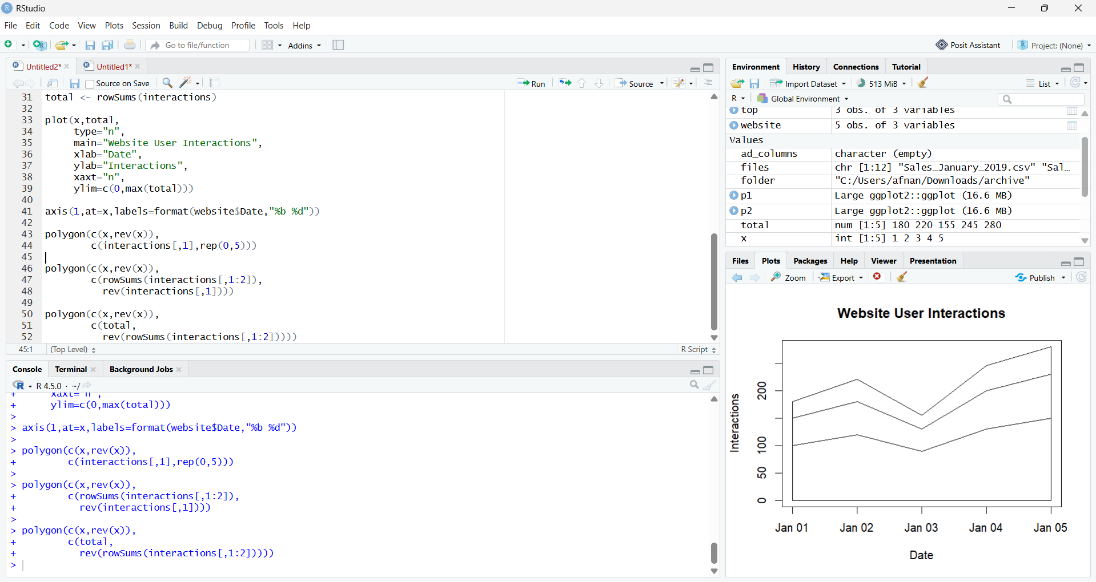

RESULT
Thus, the Website Analytics data was successfully analyzed using R programming. The line chart, bar chart, and stacked area chart were successfully created to visualize website traffic and user interaction patterns.
Note: The given Set 5 sheet provides Page Views and Click-through Rate, but it does not provide Likes, Shares, and Comments values. The interaction values used in the code are sample values solely for creating the required stacked area chart.

